EAST COAST RACE DECLARATION FORM 2023
Yacht: |  | Sail No: | Total persons on board:
Race: EAST COAST RACE – 15th JUNE 2023 |  | Class: | Start time:
Finish Time (BST): | Local Time (if not BST): | Yacht ahead: | Yacht astern:

Skipper and crew must sign this form and deliver to the EAORA Race Officer as soon as possible or if necessary leave it at the Royal North Sea Yacht Club Oostende for the Race Officer to collect. Report to the EAORA Race Officer immediately after the race finish (by telephone, SMS or WhatsApp if necessary) as per instructions in the Sailing Instructions.

SKIPPER’S DECLARATION:
“I hereby declare that I was on board and in charge of the above yacht in this race and that all the marks/waypoints were left on the require side in the correct order, all relevant rules and regulations were obeyed.” Please specify below any Penalties, Use of Engine, Discontinuation of Racing, Mark Unseen or any other relevant incidents:

Did you use an Autopilot during the race? (Allowed under rules, no penalty required) ..........Y / N

Signed: (person in charge) Date: …………...............

Please Print:........................................................................................................................................

IF IN DOUBT ABOUT RULES COMPLIANCE CONSULT THE RACE COMMITTEE BEFORE SIGNING

CREW DECLARATION:
“To the best of my knowledge and belief, other than where stated above, all relevant rules were correctly followed during the race.”

CREW | NAME &  EMAIL ADDRESS | Crew Signature  (Signature des Équipages) | RORC Member  Yes/No | Are you interested in joining the RORC?* | Tick if  Under 25
SKIPPER |  | Signed above
CREW 1
CREW 2
CREW 3
CREW 4
CREW | NAME &  EMAIL ADDRESS | Crew Signature  (Signature des Équipages) | RORC Member  Yes/No | Are you interested in joining the RORC?* | Tick if  Under 25
CREW 5
CREW 6
CREW 7
CREW 8

CREW 9

CREW 10
CREW 11
CREW 12
CREW 13
CREW 14
CREW 15
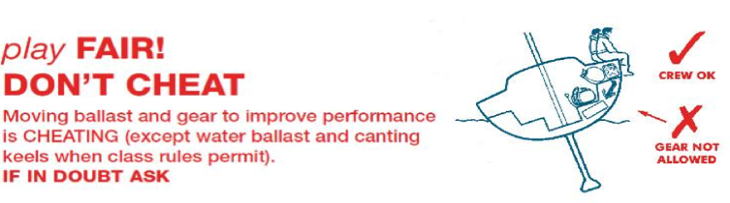
*Crew interested in joining the RORC will be sent membership information to the email address provided

