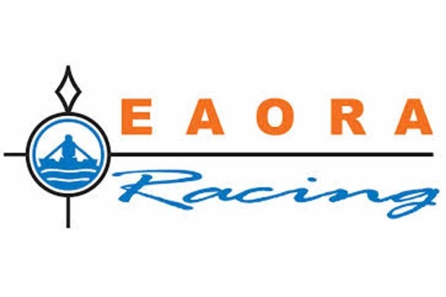
Offshore Regatta Sailing Instructions Part 2
Including amendments to the Notice of Race
Sponsored by
Formerly HAVEN KNOX-JOHNSTON

Organising Authority: East Anglian Offshore Racing Association in association with the Haven Ports Yacht Club, Royal Temple Yacht Club and the Royal North Sea Yacht Club, Oostende.

Thursday 6th July to Sunday 9th July 2017
Incorporating the following Races;
Graham Wallis Trophy (Harwich to Oostende)
Cannon Ball Trophy (Oostende to Ramsgate)
Walker Challenge Cup (Ramsgate to Harwich)

CONTACT DETAILS FOR OVERALL REGATTA
 | Race Committee | Coastguard | Race Office
From  1800  4th July 2017 | Principal Committee Vessel “Blue Horizon” a white hulled Dufour 38 Classic yacht. Call Sign “Offshore One” on VHF Channel 72  Mobile: +44 (0) 7793 372 548  Based initially in Suffolk Yacht Harbour Levington (4/7/2017) and then Ostend but in contact via phone and email with HPYC and RTYC. | Call HM Coastguard which will be answered by UK coastguard based in Dover.  VHF Channel 16  +44 (0) 01255 675518  (For Notification of retirements or in an emergency)  Zone13@hmcg.gov.uk | Until Tuesday 4th July  EAORA Secretary  Equity House  4-6 Market Street  Old Harlow  CM17 0AH  Email: eaora1949@gmail.com  Web Site:  www.eaora.org.uk
At the Finish of Regatta | Haven Ports Yacht Club.  Call Sign “Offshore One” on VHF Channel 72  Mobile: +44 (0) 7793 372 548 | As Above | Principal Race Officer Brian Bolton  at Haven Ports Yacht Club Suffolk Yacht Harbour.

YACHTS RETIRING FROM ANY RACE MUST IMMEDIATELY NOTIFY THE COMMITTEE VESSEL AT THE FINISH OF EACH RACE OR THE COASTGUARD AS APPROPRIATE.
Failure to comply may lead to exclusion from future EAORA racing.

THE ATTENTION OF EVERY PERSON IS DRAWN TO ISAF SPECIAL REGULATION 1.02 AND TO THE IMPORTANCE OF HAVING SUITABLE AND ADEQUATE PERSONAL INSURANCE.

THE FOLLOWING INSTRUCTIONS APPLY TO ALL THREE RACES.

LATEST INFORMATION
The Principal Committee Vessel, “Blue Horizon”, a white hulled Dufour 38 Classic yacht (Call Sign – Offshore One), will be moored initially in the Suffolk Yacht Harbour (Levington) on Tuesday 4th July and then move to Yacht Club Marina in Oostende on Wednesday 5th July. The Principal Race Officer, Brian Bolton, will be on board this vessel until Saturday 8th July when the Committee Vessel will travel to its Home Berth at West Mersea. On Sunday 9th July, the Principal Race Officer will travel on to the Haven Ports Yacht Club by car to be ready to compile the results ready for the Prize giving.

A second Committee Vessel “Amazon” a white Hulled Jeanneau 38 yacht (Call sign Offshore One) will also be based at Suffolk Yacht Harbour on Tuesday 4th July. The Assistant Race Officer, Tony Merewether will be on board and will provide the Start Boat at Harwich on Thursday 6th July. After the start this Committee Vessel will make her way to Ramsgate, where she will assist to Finish the Cannon Ball Race and Start the Walker Challenge.

NAVIGATION NOTES
Due to the navigational and Wind farm changes that have taken place in the vicinity of the Sunk and the introduction of the Sunk Inner Precautionary Area it is important that all entrants have up to date charts covering that area and pay due regard to the Precautionary Notes. It is advisable to monitor VHF 14 while in this area and be aware of shipping movement.
Competitors are reminded of their obligations to comply with rule 10, Traffic Separation Schemes, of the IRPCAS.
Competitors are reminded of EAORA Sailing Instructions Part 1 para. 13.5 “where a mark is not seen” when the position is passed the yacht must make and retain the most accurate recorded position of her course and track.

GENERAL RECALLS
Should a Class start be “general recalled‟, the start recalled will be restarted as soon as possible. The recalled start does NOT go to the end of the sequence. The start of Classes yet to be started will be delayed accordingly. (RRS 29.2 also refers)

COMMUNICATION
The Race Committee may broadcast information on VHF Ch72, and yachts are reminded to keep a watch on VHF Ch72 during the start and at the finish of each race.
Yachts are reminded of their legal obligation to keep a continuous watch on VHF ch16

The Race Officer at each finish will confirm with UK Coastguard the safe arrival of all vessels completing each race.

RETIREMENTS
Yachts retiring should inform the PRO or RO at the finish of each race as soon as possible by telephone or VHF ch72 or inform the Coastguard on +44 (0) 1255 675518 or by VHF that they have retired and what course of action they are taking.

REPORTING IN A SLOW RACE
When such time has elapsed that a yacht can at best achieve an average speed to the finish of less than 4 knots, she shall make every effort to inform the race office at the finish or UK Coastguard, Channel 16 or Tel: +44 (0) 1255 675518 of her position and progress, and shall continue to do so at reasonable intervals until she reports finishing or retiring.

APPROACH TO THE FINISH
All yachts are required to set listening watch on VHF Ch72 when approximately 30 minutes from the finish and at that time to call the Committee Vessel to advise Estimated Time of Arrival. At night or in poor visibility yachts should assist with identification at the finish line by calling the Committee Vessel on approach. The PRO will maintain a watch on VHF Ch72 and mobile phone, see individual notes for each finish below.

The Races will be monitored using AIS but competitors should be aware that a Committee Vessel may not on be the finish lines. Yachts are required to take their own finish time (BST) and to supply the Race Officer at the finish with that information along with details of the method of taking the time. If this is a separate watch then that watch must be checked against the official time clock. That time(BST), boat name & Sail number, yacht ahead, yacht astern should be text to the Race Officer at the finish as soon as convenient, see mobile number for each race.

DECLARATIONS
Competitors are reminded that under EAORA Sailing Instructions Part 1 15.1 they are required to complete a Declaration Form either by paper copy or by text. Yachts shall complete the Declaration and submit it to the Race Officer at the finish as soon as possible after the race. In the event of a yacht not entering the finish port, the Declaration maybe e-mailed to eaora1949@gmail.com or sent by text. Failure to comply with this rule may result in the yacht being excluded from the results. When a yacht retires from the race she shall write the reasons on her Declaration Form.

SCORING
EAORA will supply all race result details as soon as possible after each race and arrange a prize giving.
Endorsed EAORA club yachts will be extracted from the results and rescored within the EAORA classes and awarded points within the EAORA series.

THE GRAHAM WALLIS TROPHY RACE
Part 2 Sailing Instruction that apply only to this race on Thursday 6th July 2017.

COURSE TO BE SAILED (Amends the Notice of Race)
The course to be sailed will be indicated by the Code Flag Displayed by the Committee Vessel and maybe broadcast on VHF 72; either Course A or Course B.
Course A: Cliff Foot (P); Landguard (P); Medusa (P); S. Cork (P); North East Gunfleet (S); Black Deep (S); Long Sand Head (S); Twin (S); Buitenstroombank buoy (P); Finish Line.
WARNING SIGNALS (Amends the Notice of Race)
There will be One Start
0655 (BST) - IRC Class III – Code pennant “3”; IRC Class II – Code Pennant “2”; IRC Class I - Code Pennant “1”
Refer to EAORA Sailing Instructions Part 1 for IRC class Splits.

THE START
By kind permission of Mr & Mrs T Merewether the Committee Vessel will be “Amazon” a Jeanneau 38 Yacht with a White hull flying EAORA Flags.

THE FINISH (Diagram A)
The Race officer will monitor the finish either by AIS or from the pier head as a comparison of own finish times. Please assist the Race Officer in Oostende by advising him when you estimate you are 30 minutes from the Binnenstroom Bank Buoy, and when you have finished the race and taken your own time. Record other racing yachts in front and astern using VHF Channel 72, Call sign, Offshore One or mobile telephone/text - Brian Bolton, +44 (0) 7793 372 548. Complete a Declaration and text to the Race Officer as soon as possible after mooring.

THE RESULTS
Results of the race and prize giving will take place at the Royal North Sea Yacht Club, Oostende, at 1800 local time on Friday 7th July 2017.

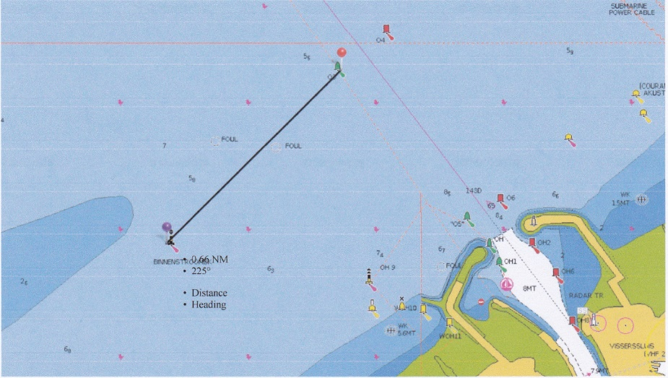
Diagram A (Not to scale and not to be used for navigation)
(The eastern end of the finish line is the O3 buoy (Green) and the western end is the Binnenstoombank East Cardinal buoy)

END OF PART 2 SAILING INSTRUCTIONS FOR GRAHAM WALLIS TROPHY

THE CANNON BALL TROPHY RACE
Part 2 Sailing Instruction that apply only to this race on Saturday 8th July 2017.

WARNING SIGNALS (Amends the Notice of Race)
0655 (BST) - IRC Class III – Code pennant “3”; IRC Class II – Code Pennant “2”; IRC Class I Code Pennant “1”
Refer to EAORA Sailing Instructions Part 1 for IRC class Splits.

THE START
By kind permission of Mr & Mrs B Bolton, the Committee Vessel at the start will be “Blue Horizon”, a white hulled Dufour 38 Classic yacht, flying EAORA Flags. The Committee Vessel will be in a position outside the Oostende harbour entrance and will have set a start line as per the Notice of Race. The Race Officer will provide the first mark of the course, then follow the course given in the Notice of Race.

THE COURSE (supplements the information in the notice of race)
On some charts the race mark “BT Ratel” is given its full name “BuitenRatelbank Buoy).

THE FINISH
The Finish Line is defined in the Notice of Race, please assist the Race Officer in Ramsgate by advising him when you estimate you are 30 minutes from the finish using VHF Channel 72, Call sign, Offshore One or mobile telephone/text - Tony Merewether, +44 (0) 7703 345 501. All yachts MUST record their own finish time as per the instruction in the notice of race. Record other racing yachts in front and astern, complete a Declaration and text to the Race Officer as soon as possible after mooring. The timepiece used should be notified to the Race Officer at the finish and if necessary a check made of that timepiece against an official clock if necessary.

DECLARATIONS
Completed declarations should be text to the Race Officer, Tony Merewether (+44 (0) 7703 345 501), on Board the Committee Vessel “Amazon” at Ramsgate as soon as possible after mooring. Please also text your declaration to the PRO, Brian Bolton +44 (0) 7793 372548 to assist with overall race results.

THE RESULTS
Results of the race and prize giving will take place in the Royal Temple Yacht Club on Saturday 8th July 2017 as soon as possible after all yachts have been accounted for by the Race Officer and provisional results can be produced. The Cannon Ball Trophy will be presented at the RTYC, but the winner will not be able to take it home.

END OF PART 2 SAILINING INSTRUCTIONS FOR THE CANNON BALL TROPHY

THE WALKER CHALLENGE CUP RACE
Part 2 Sailing Instruction that apply only to this race on Sunday 9th July 2017.

WARNING SIGNALS (Amends the Notice of Race)
0855 (BST) - IRC Class III – Code pennant “3”; IRC Class II – Code Pennant “2”; IRC Class I Code Pennant “1”
Refer to EAORA Sailing Instructions Part 1 for IRC class Splits.

THE START (Amends the Notice of Race)
Which option below will be decided by the Race Officer at Ramsgate, Tony Merewether and communicated to the Fleet either at the Prize giving or by VHF72. Both methods may be used to confirm competitors are aware of the arrangements.
Option 1 will be as detailed in the Notice of Race.
Option 2 will use the Committee Boat (Amazon) positioned near the RTYC Outer Distance mark (51 – 19.13N 01 – 25.5E). For this option the Outer distance Mark will be the Red Port Entry Mark on the end of the Southern Breakwater. Yachts should start in an easterly direction leaving the Committee Boat to Starboard and the Port Entry mark to Port.

THE FINISH
The finish line is defined in the Notice of Race, please assist the Race Officer in Harwich by advising him when you estimate you are 30 minutes from the finish using VHF Channel 72, Call sign, Offshore One or mobile telephone/text – Brian Bolton, +44 (0) 7793 372 548. Once you have recorded your own finish time as per the instruction in the Notice of Race, please text that time. Own yacht name & sail number, Yacht ahead, yacht astern to the Race Officer to assist with overall race results.

THE RESULTS
Results of the race and prize giving will take place in the Haven Ports Yacht Club as soon as possible after the last yacht finishes, followed by the results and prize giving for the overall regatta. A time will be notified to all skippers by Text Message.

END OF PART 2 SAILING INSTRUCTIONS

Additional Notes for Competitors
(These notes are NOT part of the Sailing Instructions)

BERTHING ARRANGEMENTS
At Suffolk Yacht Harbour
All yachts are required to register with the Harbour master, berth as instructed and pay the appropriate fee for each nights berthing.

At Ramsgate and Ostend
All yachts are required to register with the Harbour master in each marina and berth as instructed. EAORA have negotiated a discounted group rate which you will have paid as part of the entry fee, the Race Officer will pay for berthing for all EAORA entered Yachts.

CATERING ARRANGEMENTS
No official arrangements have been planned so crews should make their own arrangements for catering at each port. Arrangements will be made for prize giving at all three ports, see part 2 Sailing Instructions.

SUFFOLK YACHT HARBOUR
At the Haven Ports Yacht Club on Wednesday evening the bar will be open from 18.00 until 23.00 and bar food will be available from 18.00 until 21.30, but it is recommended that you Book for Dinner with HPYC – 01473 659 659 and eat before 20.00 as after that time the menu is reduced and the Wednesday night local race fleet arrive in the bar and it can get very busy.
On Sunday the bar is open all day until 22.30 and bar food is available from 18.00 until 21.30.

OOSTENDE
There are various bars and restaurants in Oostende to cater for all tastes and costs, the RNSYC will be open but you will need to book ahead or as soon as you arrive, they have been given notice of the event and will try to accommodate as many as possible. The Cosy Corner is well known to most of the fleet and is a good meeting place later in the evening.
The intention is to hold a prize giving at the Royal North Sea Yacht Club, Oostende, at 1800 local time on Friday 17th June 2016.

RAMSGATE
After crossing the finish line please take due regard of the entry lights when entering Ramsgate and it is advisable to call Ramsgate Port Control on Channel 14 for permission to enter and when leaving. The marina should then be contacted on Channel 80 for a berth advise them you are part of the EAORA race Fleet

The intention is to hold a prizegiving at the Royal Temple Yacht Club depending how early the fleet finish and results can be finalised. There will not be any catering at RTYC, competitors should make their own arrangements in the town hostelries.
End of additional Notes

